BACHELOR OF BANKING & INSURANCE
Following is the list of students who are granted permission to appear for re-exam of class test SEM I December - 2021 on technical and exceptional grounds:

Sr.no. | Name of the student with roll no. | Course in which to appear | Time of exam
1 | 1054 -  KADAM PRIYANKA ANKUSH SHARADA | PRINCIPLES OF MANAGEMENT | 2.30pm to 3.00pm
Note:
The re-exam will be held on WEDNESDAY , 15th December, 2021. The google meet link for the same is Video call link: https://meet.google.com/xvy-fcqu-ivb

If the student fails to give his exam as mentioned above then no further chance will be given and earlier status will be reflected.
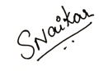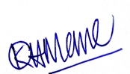
Durgesh Kenkre Prof. Subhashini Naikar Dr. Kiran Mane
Exam Convenor Vice Principal, SFC I/c Principal
Date: 10/12/2021.
DI/N-STD/GEN/00

