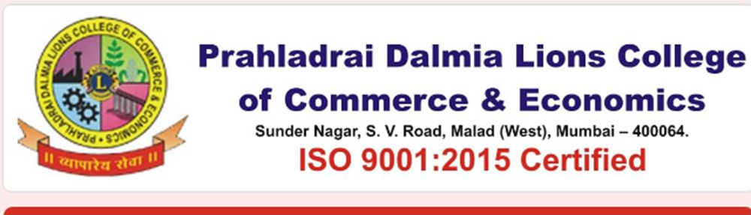

Students’ Council Report 2021-22

Members of the Students’ Council of the College are given an exposure to involve themselves in the various administrative, co-curricular and extracurricular activities by including them as members of the respective committees. They actively participate in various activities organised by the concerned committee .The following is the list of Committees having student representation and engagement.
- Class Committee( Class Representatives)
- Magazine Committee
- Sports Committee
- Admission Committee
- Cultural Association
- Internal Quality Assurance Cell
- Anti-Ragging Cell
- Library Committee
- Grievance Redressal Cell
Class Representatives:
All classes have two students designated as class representatives and they are the Students Council members. Clubs have well defined structure & assigned roles. The said selection has been done though the voting process in the respective class. They are responsible for representing any issues related to academics/non-academics to concerned HODs/Class teacher.
Principal and Vice Principals interacts with class representatives’ at-least once during the semester. Meeting of members of the Council are conveyed on time to time
Students as Member of Organising Committees in Cultural and Sports Activity:
Students have strong representations in all Cultural and Sports Committees and they help in organization and management of events. Major events include Celebration of Days under the banner of Students Council, Dalmia Lions Utsav, Annual Day, Annual sports competition and Annual Sports Day etc where in Members of Council plays a vital role in organising the events.
Administrative Support: Students provide strong support in the administration and management of institute affairs. Students are involved in the admission process of the college. They are involved in all major decision-making aspects related to students.
Placement Committees: student members are important components in placement activities. They involved for coordinating the activities during placement drives at campus.
Technical Events: student members are actively involved in organising Debate Competition, participants in the various conferences whereby for all the Administrative activities at department/institute level. Some of these activities include conferences, coding & project contests, quiz competitions, student council activities etc.
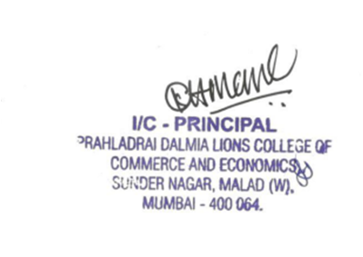

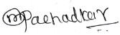
Dr. Mahendra Pachadkar
Convenor- Students Council

DI/ N-STD/GEN/00

Virtual Conference on

“Being Resilient Responsible and Responsive” 2021- 22
About the Conference:
Challenges like COVID-19 Pandemic are like one in a century. It will vanish one day for sure. But, it is worth noting that it has realized us what we are and what we have to become. Stress and turbulence are part of human life. The Human Race has survived only due to victorious survival over the odds. Moreover, this crisis has made us realized in what direction, with what magnitude we need to progress and evolve ourself to be able to exist in more meaningful manner. We need to become one who is able thrives, go longer and able to connect to every other existing with us. Moral: We need to be more resilient not to fail easily, also we need to take responsibility of all our deeds, and be responsive to each and every change happening around us, close and far away.
On the above background and the need of an hour Students’ Council of Prahladrai Dalmia Lions College had organised a One Day National (Virtual) Conference on “Being Resilient Responsible and Responsive” in association with Internal Quality Assurance Cell on 3rd February 2022 at 11.00 am by Dr. Amruta Bhuskute- IQAC Co-ordinator & Asstt. Professor. Department of Psychology, Smt. Binzani Mahila Mahavidyalaya, Nagpur. Almost 165 participants had attended the same.
(Link of Feedback-Attendance)
https://docs.google.com/spreadsheets/d/1lYmNMOQ8JeSeespavAL62iBtUn1saab8VsVyzRuBPP0/edit?usp=sharing
( Link of Photographs and Flyer)
https://drive.google.com/drive/folders/1WOYDrWI_HxmpVUlRJTqDa1bCZ-fUG06x?usp=sharing
Dr. Mahendra Pachadkar
Convenor- Students’ Council

