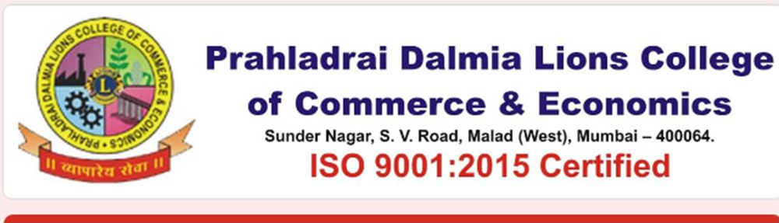
UNFAIR MEANS INQUIRY COMMITTEE
The Unfair Means Inquiry Committee is a part of the Examination System, appointed to investigate the matters of Unfair means reported at the time of examination.
Students are made aware of the consequences of using unfair means on the first day of commencement of examination. Cases are reported by the Junior Supervisor, to the Sr. Supervisor. The Student gives a statement as well as undertaking for further due process is followed as given by the University.
Students are called for hearing after examinations are over and the paper is shown to the concerned subject teacher. If found copied teacher marks portion as “exhibit”. In due course student is informed about the judgement.
Mrs. Sharada Gaitonde

Convenor- Unfair Means Inquiry Committee.

Dr. Shami Nimgulkar Kamble- Member

Ms. Harshada More- Member

