PRAHLADRAI DALMIA LIONS COLLEGE OF COMMERCE AND ECONOMICS.

One Day Workshop
ON
Intellectual Property Rights (IPR)
Report

NATIONAL WORKSHOP
ON
‘INTELLECTUAL PROPERTY RIGHTS

ON 1ST MARCH 2023

About the Conference:
In today’s universally competitive environment, intellectual property has placed itself on a plinth in the context of economic growth and is becoming increasingly important.
Intellectual Property is the invisible property and fuel that energise the engine of prosperity, fostering invention and innovation. The increasing importance of intangible assets in the global economy is making business organizations to actively manage their IP as a key driver for building and sustaining their competitive advantage and achieving superior performance compulsorily. To create awareness about the need and importance of Intellectual Property Rights (IPR) among the faculty and students through periodic workshops. To facilitate filing of applications for patents and other IPR.
On the above background, Dr. Kiran H. Mane I/C Principal, organised a One Day Worksop on Intellectual Property Rights entitled by Department of Business Law in association with Internal Quality Assurance Cell of the College. on 1ST March 2023 at 10.00 am
The workshop was conducted by Professional and Academician Dr. Hema Mehata, a Senior Associate Professor Tolani College of Commerce having over 20 years of experience in the Intellectual Property Rights Issues.
Dr. Hema Mehata provided comprehensive awareness on contemporary IP issues pertaining to Commerce and Industry with the with the help of leading case studies of corporates like Mahindra and Mahindra, Cleartips, and Reliance Jio. Throughout his presentation he addressed various IP related plagiarism issues that occurs with the participants during their academic years and initial industrial exposure. Further, participants were taught on how IPR restricts copying others’ ideas and how this will help the development of new ideas for the benefits of the society.
The said workshop created a great impact on the entire audience, The Workshop was highly informative to students, teachers. Almost 400 Students and Teachers had participated in the said workshop.
The workshop ended with the Vote of Thanx by Dr. Mahendra Pachadkar (HOD) followed by National Anthem
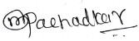
Dr. Mahendra Pachadkar.
Head of the Department
Business Law.

GLIMPSES
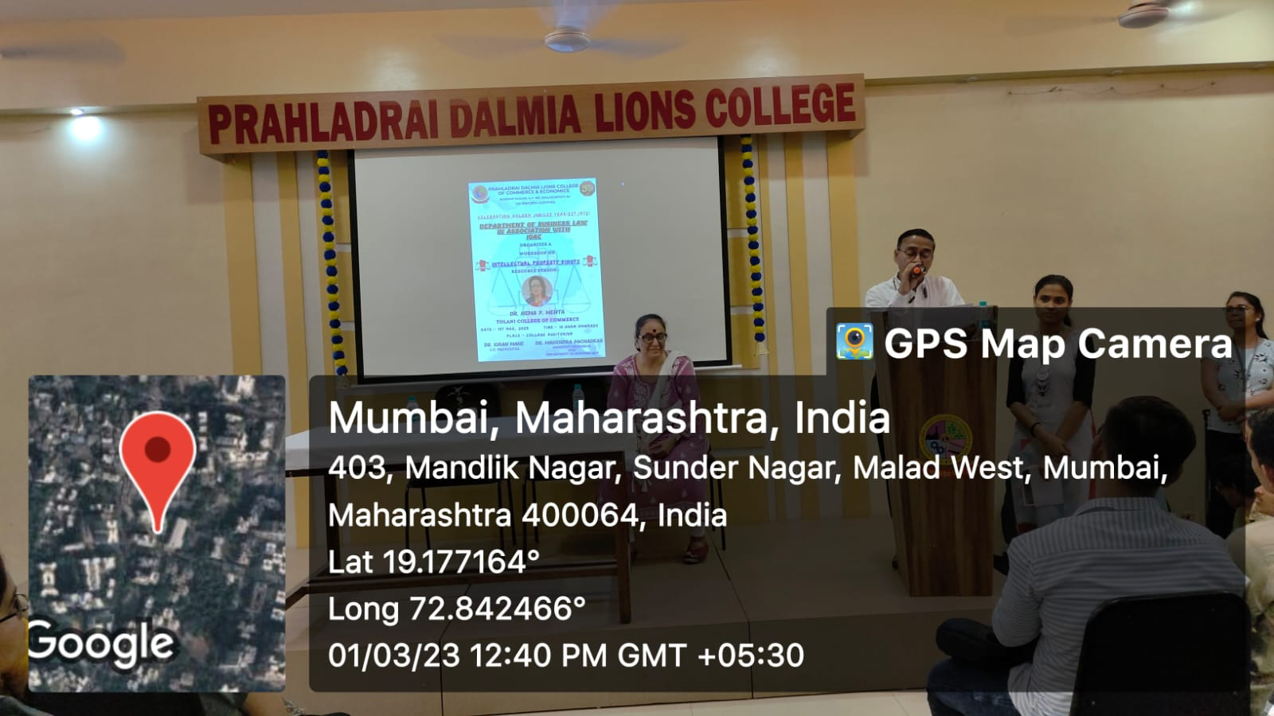 | 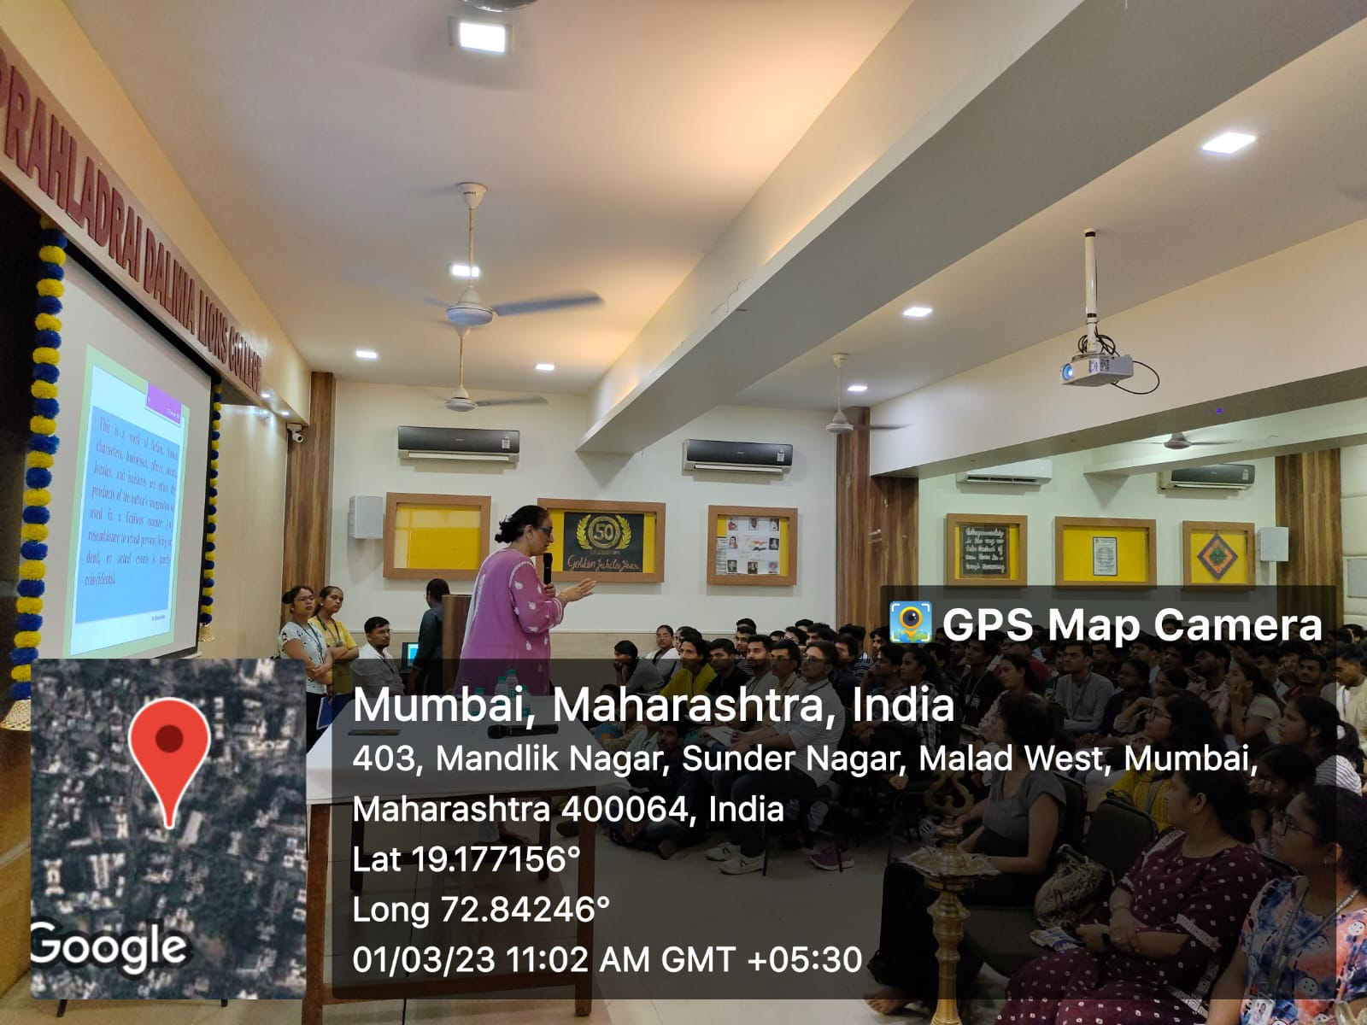
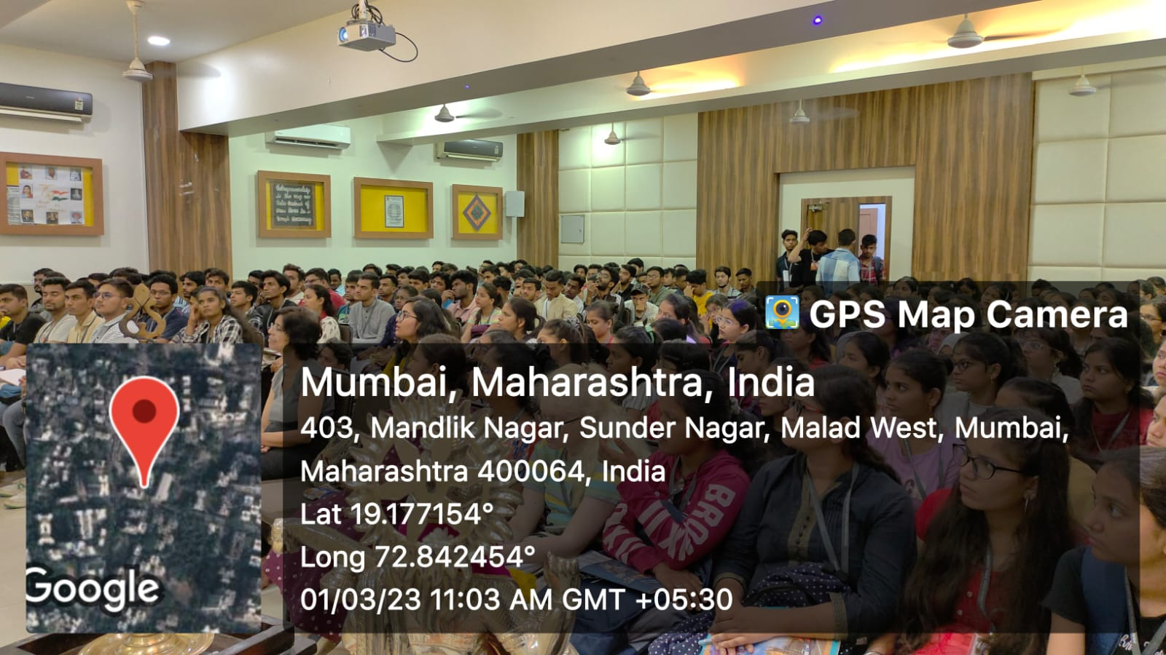 | 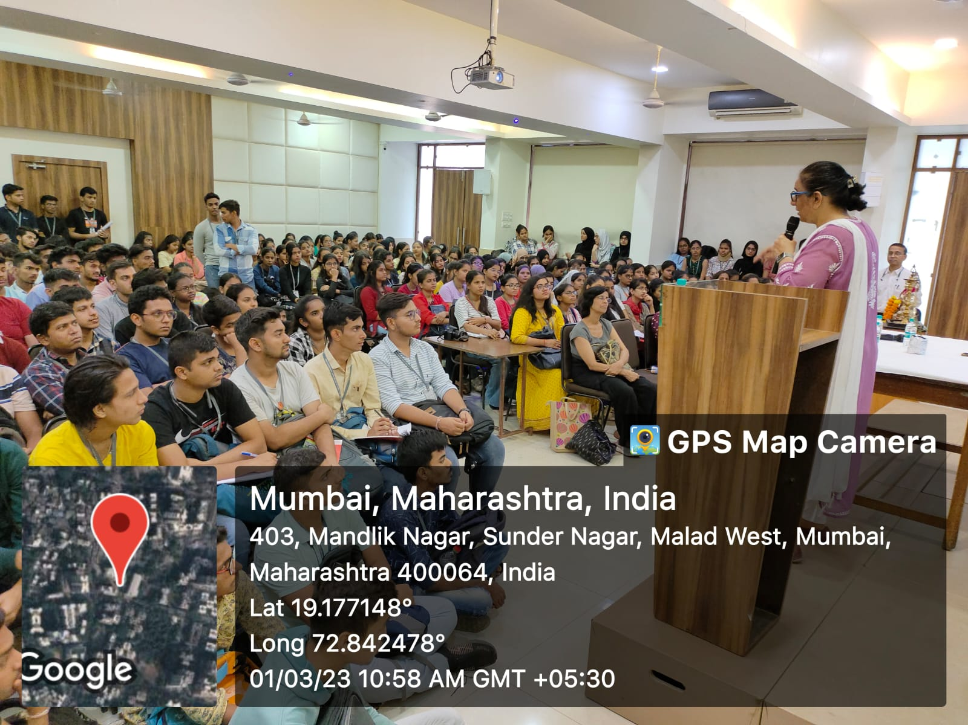
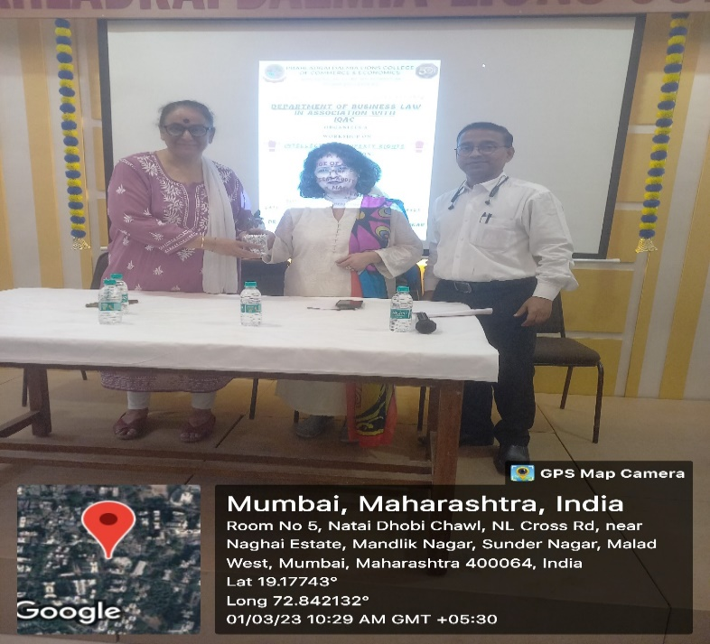 | 