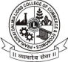
Prahladrai Dalmia Lions College
of Commerce & Economics
50 Years of Sterling Performance in Education
Sunder Nagar, Malad (West), Mumbai, 400 064
ISO 9001: 2015 Certified

Date: 9th January, 2023
NOTICE
ANNUAL DAY 2022-23
LITERARY ARTS Competition (29 January 23)

Students of Degree, Self-Financed Courses and Junior College who wish to participate in the (Literary Arts- JAM, TELL A TALE, ELOCUTION, SELF COMPOSED POETRY) competitions for the Academic Year 2022-23 are required to fill up the registration form and join WhatsApp group (Links given below)

NOTE: LAST DATE OF REGISTRATION – 15TH JAN, 2023
Link: https://forms.gle/Hz7oHp8SkDA67afh9
WhatsApp: https://chat.whatsapp.com/BInBXsSABCSDRyEUMpraAN

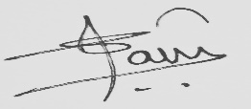
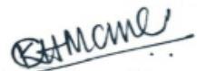
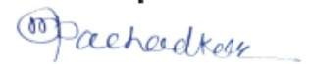
Tanvi Shah Dr. Mahendra Pachadkar Dr. Kiran Mane
Literary Arts Incharge Convenor – Students’ Council I/C Principal

DI/N -STD/GEN/00

