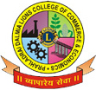

PRAHLADRAI DALMIA LIONS COLLEGE OF COMMERCE & ECONOMICS
Sunder Nagar, Malad (West),Mumbai, 400 064
ISO 9001:2015 Certified

Date: 10-01-2022
NOTICE

F.Y.B.Com. 2021-2022

The F.Y.B.Com. students of academic year 2021-2022 are hereby informed that they are required to fill the Google form (link mentioned below) for Examination result purpose on or before 12-1-2022 upto 5.00 p.m.
*Google Form Link: https://forms.gle/aZWHihT2AhoairuR6

Note:
The online form filling (only for first year learners) for examination purpose for which kindly keep the following documents with you ready:
1) Photocopy of HSC Marksheet.
2) PRN number (Please refer to the list uploaded on the website).
3) Soft copy of Passport size formal Photograph as mentioned below in sample.
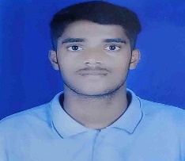
SAMPLE PHOTOGRAPH IN JPG FORMAT

4) If students fail to fill Google form as (date mentioned above) than college will not be responsible for the same.

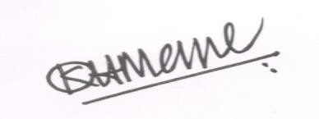
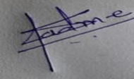 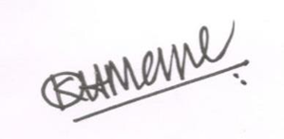 Dr. Shiva Padme Dr. Kiran Mane
Convenor, Exam Committee I/c Principal
DI/N-STD/Gen/00

