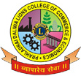

**PRAHLADRAI DALMIA LIONS COLLEGE OF COMMERCE & ECONOMICS**

Sunder Nagar, Malad (West),Mumbai, 400 064

**ISO 9001:2015 Certified**

**NOTICE**

**Date: 2-12-2021**

**B.Com Sem VI A.T.K.T.**

**REV-16 /75:25**

**DECEMBER 2021**

**EXAMINATION WHATSAPP LINK**

**The students of ATKT who had filled their T.Y. B.Com Sem VI exam form & paid fees as per notice given, their examination will commence from 9th December, 2021 onwards they should Join the following whatsapp group.**

|  |  |
| --- | --- |
| **SEMESTER** | **GOOGLE LINK** |
| **SEM VI** | [**https://chat.whatsapp.com/Eq66HlHNP5qFxECUX6mfjs**](https://chat.whatsapp.com/Eq66HlHNP5qFxECUX6mfjs) |

**Note:**

**1. The link is only for A.T.K.T. (Repeater) Students.**

**2. If any student appear for the exam without filling the exam form, college will not be responsible for that & such students their result will not be declared.**

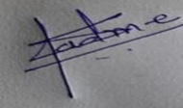 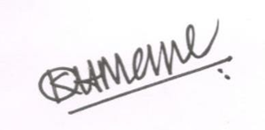 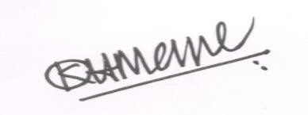

**Dr. Shiva Padme**  **Dr.Kiran Mane** **Convenor, Exam Committee I/c Principal**

DI/N-STD/Gen/00

