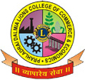

PRAHLADRAI DALMIA LIONS COLLEGE OF COMMERCE & ECONOMICS
Sunder Nagar, Malad (West),Mumbai, 400 064
ISO 9001:2015 Certified

NOTICE
Date: 13-10-2021
B.Com Sem III A.T.K.T.
REV-16 /75:25
OCTOBER 2021
EXAMINATION WHATSAPP LINK

The students of ATKT who had filled their B.Com Sem III exam form & paid fees on or before 30-09-2021 as per notice given, their examination will commence from 20th October, 2021 onwards they should Join the following whatsapp group.

SEMESTER | GOOGLE LINK
SEM III | Follow this link to join my WhatsApp group: https://chat.whatsapp.com/F6siR1KxJHMDpCLSWVxjsL
Note:
1. The link is only for A.T.K.T. (Repeater) Students. Regular Students should join their respective group.

2. If any student appear for the exam without filling the exam form, college will not be responsible for that & such students their result will not be declared.

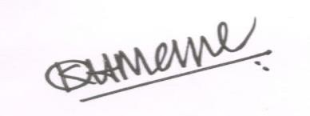
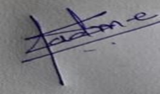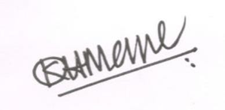
Dr. Shiva Padme Dr.Kiran Mane Convenor, Exam Committee I/c Principal
DI/N-STD/Gen/00

