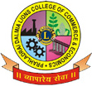

PRAHLADRAI DALMIA LIONS COLLEGE OF COMMERCE & ECONOMICS
Sunder Nagar, Malad (West),Mumbai, 400 064
ISO 9001:2015 Certified

NOTICE
Date: 22-9-2021
B.Com Sem II & Sem IV A.T.K.T.
REV-16 /75:25
SEPTEMBER 2021
EXAMINATION WHATSAPP LINK

The students of ATKT who had filled their B.Com Sem II / IV exam form & paid fees on or before 21-9-2021 as per notice given, their examination will commence from 27th Sept., 2021 onwards they should Join the following whatsapp group.

SEMESTER | GOOGLE LINK
SEM II | Follow this link to join my WhatsApp group: https://chat.whatsapp.com/BcPPBabzXvL9Nb1nK17GBP
SEM IV | Follow this link to join my WhatsApp group: https://chat.whatsapp.com/L7qFFTXF97j0iHI5jfRrwN
Note:
1. The link is only for A.T.K.T. (Repeater) Students.

2.. If any student appear for the exam without filling the exam form, college will not be responsible for that & such students their result will not be declared.

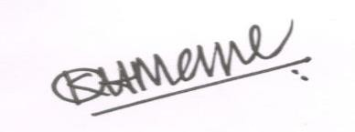
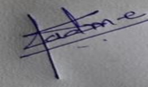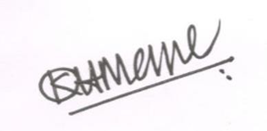
Dr. Shiva Padme Dr.Kiran Mane Convenor, Exam Committee I/c Principal
DI/N-STD/Gen/00

