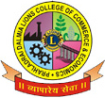
Prahladrai Dalmia Lions College of Commerce & Economics
Sunder Nagar, Malad (West),Mumbai, 400 064
ISO 9001:2015 Certified
Date: 15-12-2020.
NOTICE

F.Y.B.COM SEM I (REGULAR & REPEATER) DECEMBER 2020
MOCK TEST
All the students of F.Y.B.Com Sem I (Regular 2020-2021) and Ex-student are hereby informed that a Mock Test will be held in the subject of Accountancy and Financial Management - I as per following:

1. F.Y.B.Com Sem I – Friday, 18th Dec.,2020 between 11.30 to 12.30 p.m.

The link for the mock test will be shared 15 minutes before the exam on the respective divisions whatsapp groups.

The following link is only for the Ex- student to join whatsapp group for giving their Mock Test & ATKT exam.
Google Link (for Ex-students)
F.Y.B.Com Sem I (A.T.K.T.) –
https://chat.whatsapp.com/EAIDlMsWDiRFPcWSs2WV2S

All the Regular student please note that the link for Mock exam and Regular exam will be shared on their class whatsapp group.
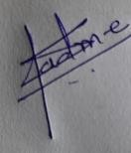
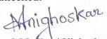
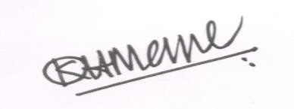
Dr. Shiva Padme Prof.Madhavi Nighoskar Dr.Kiran Mane
Exam Convenor Vice Principal I/C Principal
DI/N-STD/Gen/00

